**Denoising signals**

Experiment with Fixed-share algorithm

**Project Report**

Fang Ce *cf1883*

Junlin Liu *jl7569*

Fangfang Sun *fs1337*

Lin Qi *lq394*

Tianpei Cai tc1996

New York University

Tandon School of Engineering

Contents

1 Introduction 3

1.1 Context 3

1.2 The project 3

2 Expert Advice 4

2.1 The model of Fixed-share algorithm 4

2.2 Fixed-share algorithm 4

2.3 Expert of denoising 5

3 Results and discussion 7

3.1 Finding best alpha 7

3.2 Weight Change 8

3.3 Cumulative loss 9

4 Summary and future work 10

4.1 summary 10

4.2 future work 10

5 References 11

6 Appendix 12

6.1 TVD filter for denoising non-blocky signal 12

6.2 TVD filter for denoising blocky signal 13

6.3 Wavelet filter for non-blocky signal 14

6.4 Wavelet filter for blocky signal 15

# Introduction

## Context

To denoised digital signal is to filter out the noise, and the challenge is how to preserve the important feature during the denoising process. In the real world, the clean signal and the noise may be time-variant, however, our filter is fixed. To improve the performance of denoising for time-variant signal, we use Expert Advice Algorithm to cope with non-stationary sequence denoising problem.

To simplify the problem, we use two kinds of clean signal (blocky signal and non- blocky signal) and two kinds of noise signal (Gaussian noise with different covariance). Each expert is specifically designed to deal with a certain kind of signal, which includes the clean signal and the noise.

## The project

For Expert Advice algorithm, each expert can be seen as black box, the result of each expert has been placed in the appendix.

# Expert Advice

## The model of Fixed-share algorithm

As our input signal is non-stationary sequence, we choose to use fixed-share algorithm to denoising our signal. The model for our system is showed in the Figure **2**‑**1**:

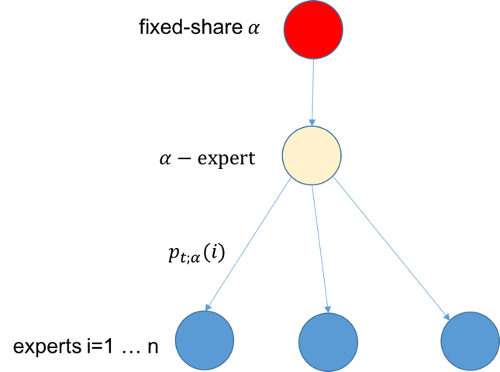

Figure 2‑1 The model of fixed-share algorithm

Our system calculates the current loss for each expert and update their corresponding weight $p_{t;α}(i)$.

We compare the cumulative loss for every expert and evaluate the performance of our system. To select the best alpha, we change the value of the alpha for each expert, and then select the best alpha for our system.

## Fixed-share algorithm

INPUTS: Signals $(a_{1},a_{2},a_{3},…,a_{n})$

$k$ $k$: number of experts.

Initialization: $p_{1}\left(i\right)=1/k$ $p_{1}\left(i\right)=1/k$, for all $i ϵ \{1, 2,…k\}$

For $t=1,2, …$

Received data point $y_{i}(t)$ in the stream

For each $i ϵ \{1, 2,…k\}$

Compute the loss for each expert: $L_{t-1}(i)$

Update $p_{t;α}\left(i\right)$

Notice:

$$p_{t;α}\left(i\right)=\frac{1}{Z_{t}}\sum_{j=1}^{k}{p_{t-1}\left(j;α\right)*}e^{-ηL_{t-1}(j)}*p\left(i|j;α\right)$$

$$Θ_{i,j}=p\left(i|j;α\right)=\left\{\begin{aligned}1-α, i=j \\ \frac{α}{k-1},i≠j\end{aligned}\right.$$

$$Z_{t}=\sum_{j=1}^{k}{p_{t;α}\left(i\right)}$$

$L_{t}\left(i\right)=L_{t}\left(y_{i}\left(t\right),x\left(t\right)\right)=\frac{1}{N}\sum_{j=1}^{k}{{(y_{i}\left(t\right)-x\left(t\right))}^{2}}$, the loss of expert $i$ at time $t$.

## Expert of denoising

### TVD1

Total variation denoising (TVD) is an approach for noise reduction developed to preserve sharp edges in the underlying signal.

Total variation denoising assumes that the noisy data $y\left(n\right)$ is of the form:

$y\left(n\right)=x\left(n\right)+w\left(n\right),n=0,1,…,N-1$

where $x\left(n\right)$ is a (approximately) piecewise constant signal and $w\left(n\right)$ is a white Gaussian noise.

The TV denoising problem can be written compactly as

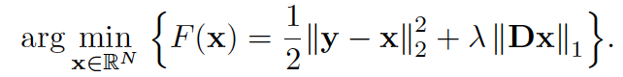

which can be written as,

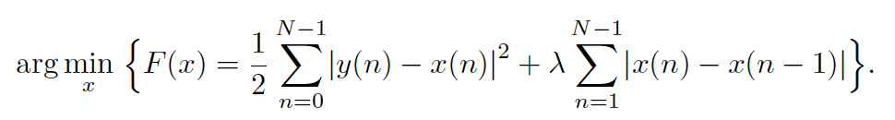

 The matrix $D$ is defined as

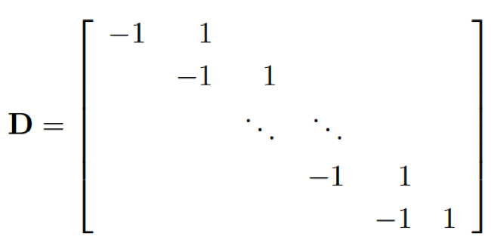

An upper bound (majorizer) of $f\left(t\right)=|t|$ that agrees with $f\left(t\right)$ at $t=t_{k}$ is:

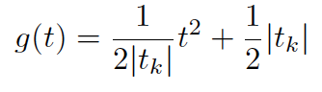

Using MM algorithm, we can obtain:

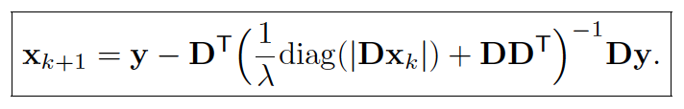

The regularization parameter $λ>0$ controls the degree of smoothing.

Total variation (TV) denoising is a method to smooth signals based on a sparse-derivative signal model. TV denoising is formulated as the minimization of a non-differentiable cost function. Unlike a conventional low-pass filter, the output of the TV denoising `filter' can only be obtained through a numerical algorithm. Total variation denoising is most appropriate for piecewise constant signals, however, in the feature, it can be modified and extended to be effective for more general signals. Here, we generate a second order TVD filter for non-blocky signal.

### TVD2

A modified TVD1 filter to a second order TVD filter, which has better performance on non-blocky signal.

### Wavelet denoised filter

For Wavelet denoised filter:

1. Firstly, the received signal levels are separated by wavelet transform. Then, the received signal wavelet coefficients are calculated up to the desired level.
2. the variance ($σ^{2}$) of the noise is calculated using the wavelet coefficients:

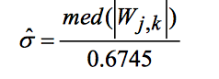,

where med(.) denotes the median.

1. The threshold value is calculated using the variance.

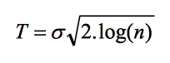

1. Performing the hard-thresholding.
2. The original signal is reconstructed using the inverse wavelet transform and retained coefficients.

There are two experts in our system for wavelet denoised filter: wavelet denoised filter-harr and wavelet denoised filter-symlets. Harr wavelet is used for the blocky, while symlets wavelet is used for the non-blocky signal.

We set the level = 3.

# Results and discussion

## Finding best alpha

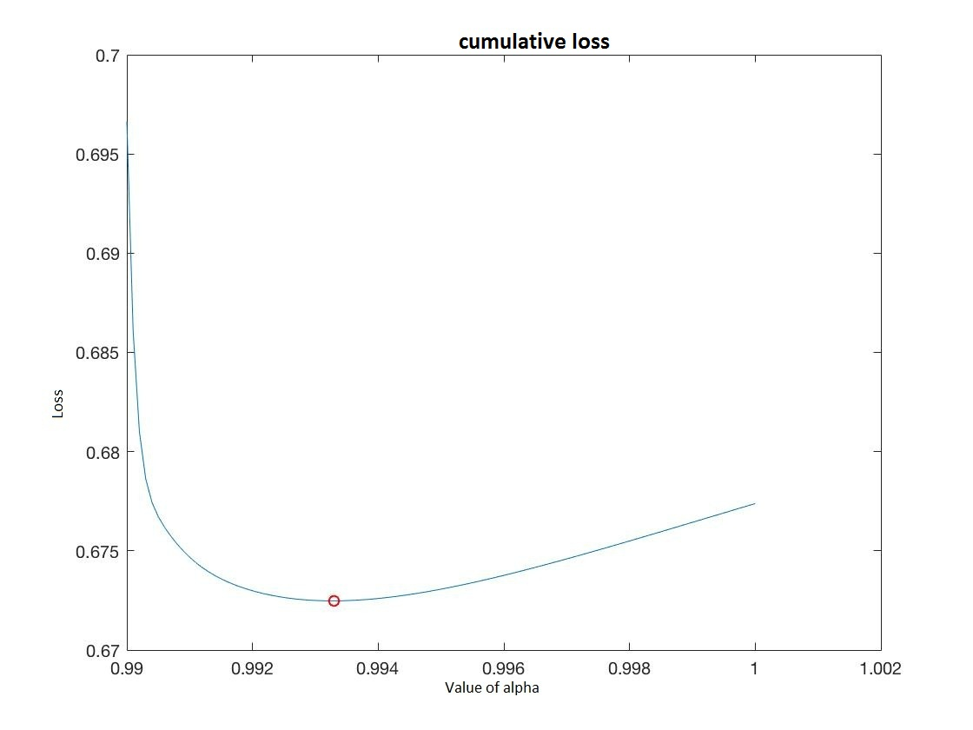

Figure 3‑1 Curve of the cumulative loss function in our system

Figure **3**‑**1** shows how the cumulative loss function changes based on the value of alpha. Our cumulative loss function is convex, the global minimum will be obtained when alpha is 0.9932, and the minimum loss is 0.6731.

## Weight Change

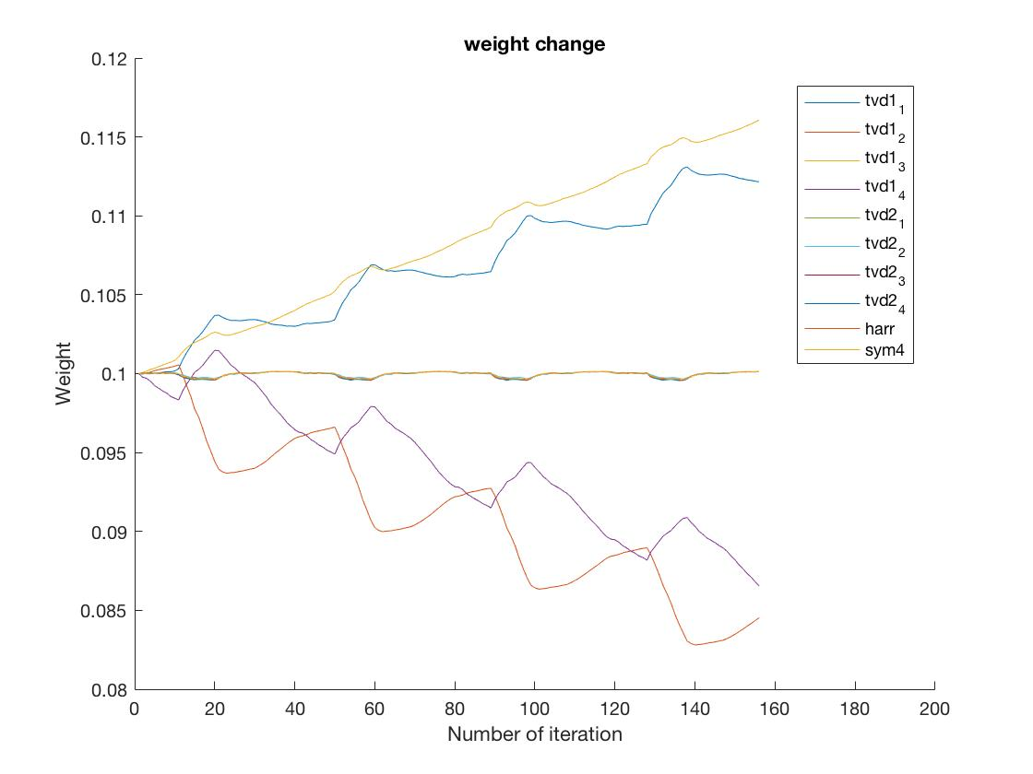

Figure 3‑2 The evolution of weights over different experts over time

Figure **3**‑**2** shows how the weight of each expert changes at different iterations. From this figure, we can clearly see that, expert tvd11 and expert tvd24 always perform better than other experts, and expert tvd12 and tvd14 always perform worse than others, since our noise and clean signal is not abundant enough, those experts just don’t meet the right noise. However, at different step, the identity of best expert is changed, which means our algorithm has the ability to cope with the non-stationary input sequence by adjusting the weight of each expert at different time.

## Cumulative loss

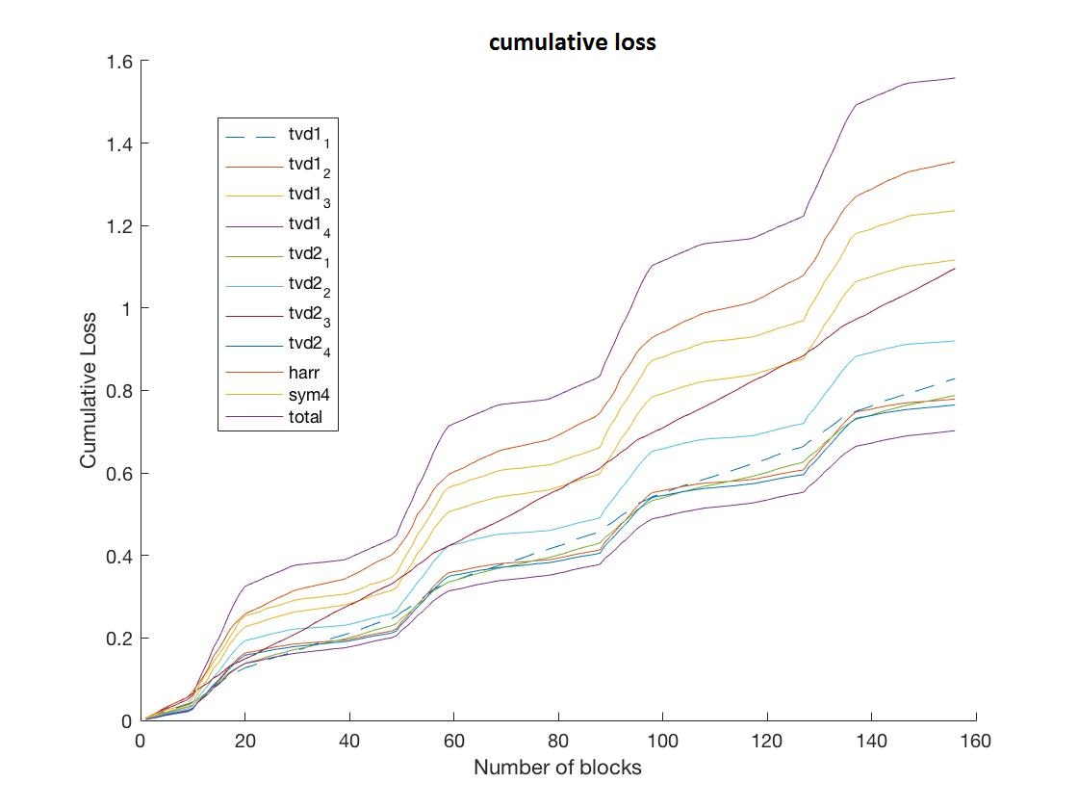

Figure 3‑3 The evolution of cumulative loss over different experts over steps

Figure **3**‑**3** shows the cumulative loss of each experts at each block. Our system has the minimal total loss almost every step, which means the algorithm used in our system is working in this situation. It turns out our algorithm can be potentially useful in signal denoising problem in our real world.

# Summary and future work

## summary

From figures above we can see that, our expert advice algorithm can generate the denoised signal with least loss, as it wins with each of this method run by itself.

## future work

In our project, we just deal with one-dimension signal with Gaussian white noise. In the future, we would like to denoised two-dimensional signal, such as image, where the TVD filter is widely used.

At present, our fixed-share algorithm with switching rate works well on non-stationary sequence, in the future, we would like to work on learn- $α$ algorithm, which can find the best expert to denoising signals even without the signals’ type and distribution. Hopefully, it will save us amounts of time to find the best correspondent coefficient of the filter to denoised the input signal, since if we don’t have the estimation of input signal’s distribution, we may need a lot of experts to generate a satisfied result, which will result in the increase of calculation.

# References

Enter text

# Appendix

## TVD filter for denoising non-blocky signal

### tvd1

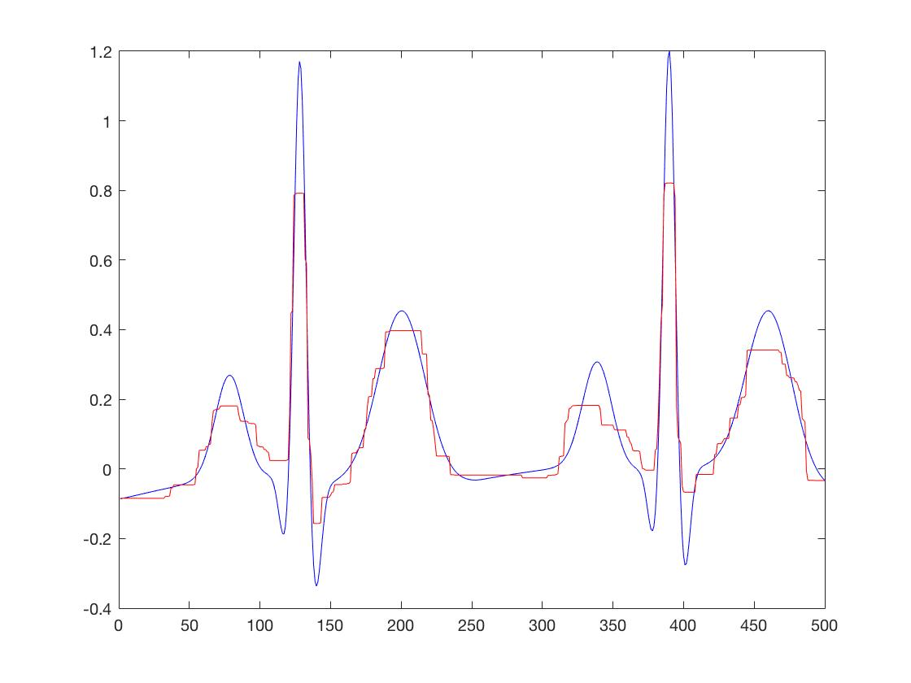

Figure 6‑1 tvd1 filter for denoising non-blocky signal

### tvd2

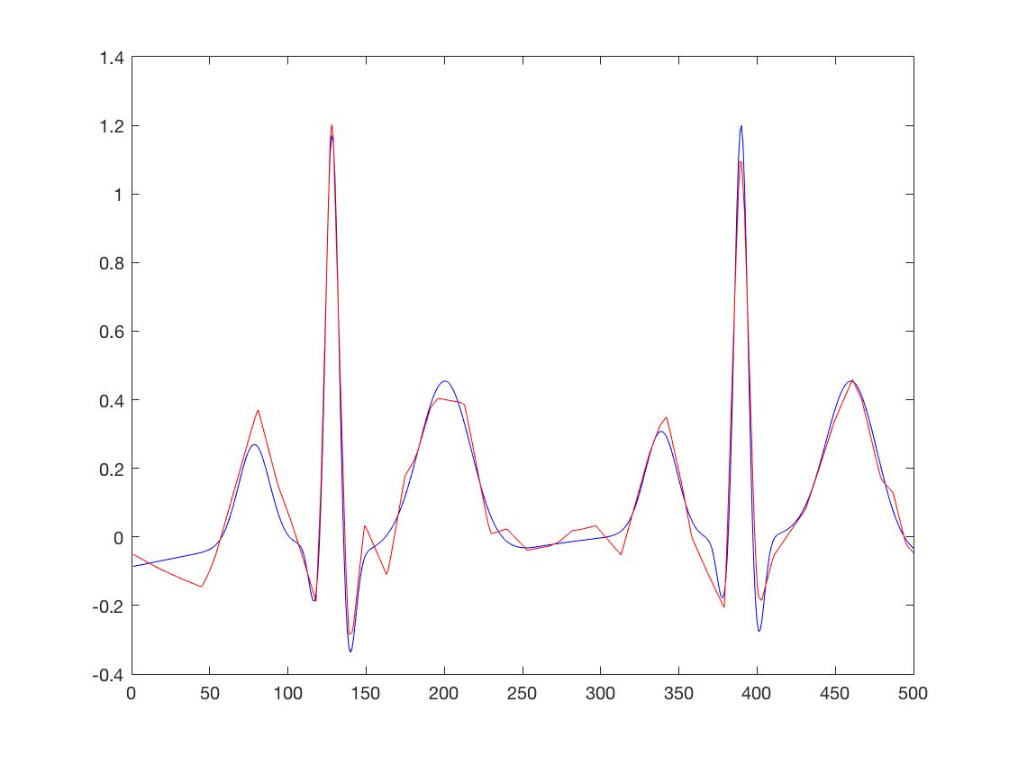

Figure 6‑2 tvd2 filter for denoising non-blocky signal

## TVD filter for denoising blocky signal

### tvd1

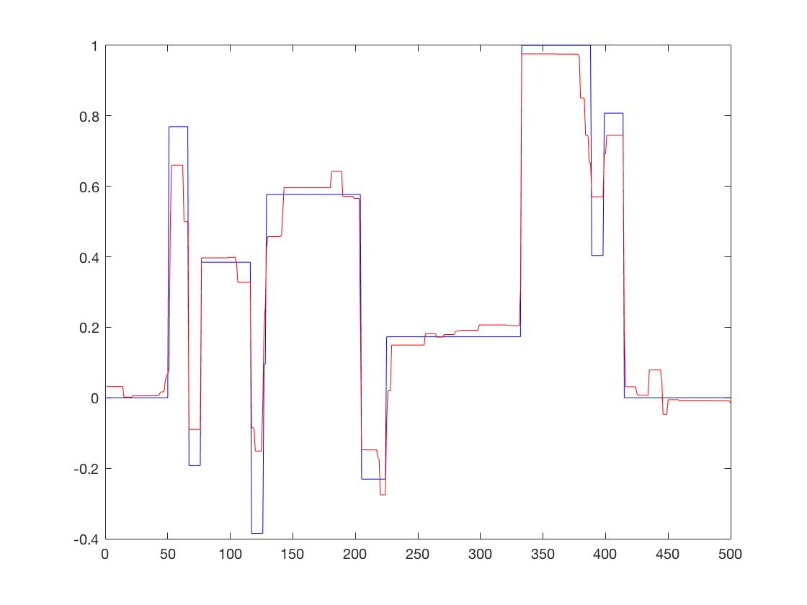

Figure 6‑3 tvd1 filter for denoising blocky signal

### tvd2

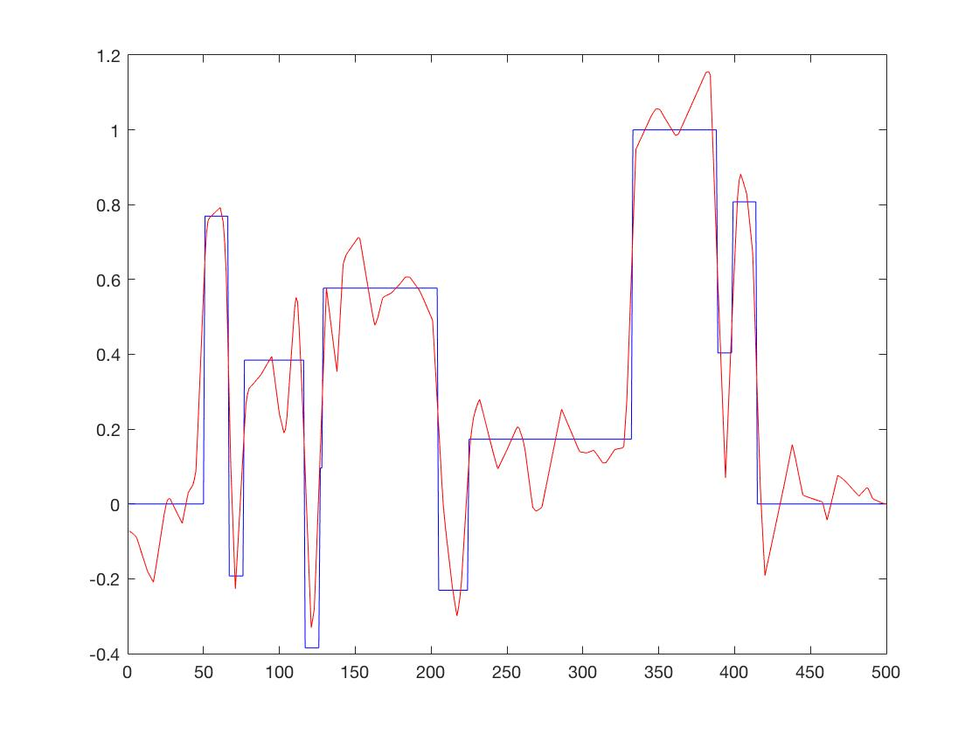

Figure 6‑4 tvd2 filter for denoising non-blocky signal

## Wavelet filter for non-blocky signal

### harr

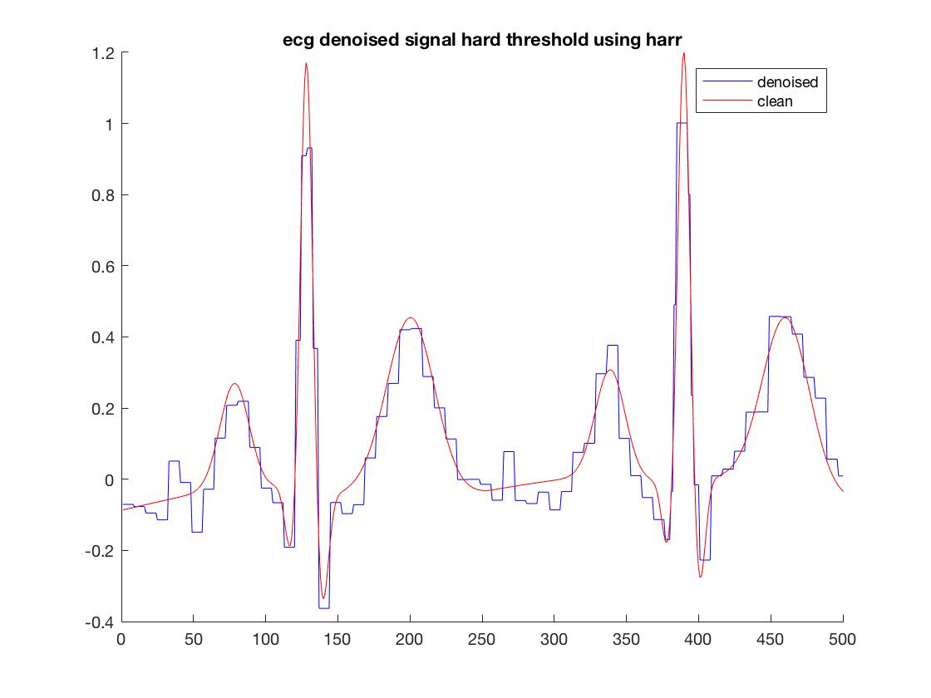

Figure 6‑5 wavelet filter-harr for denoising non-blocky signal

### sym4

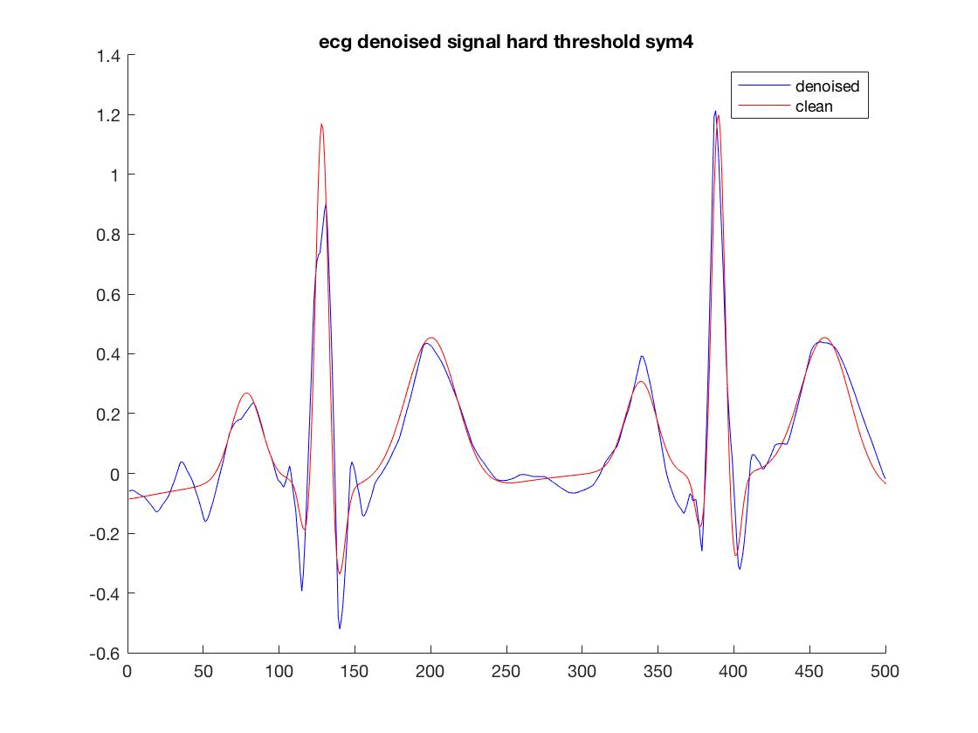

Figure 6‑6 wavelet filter-sym4 for denoising non-blocky signal

## Wavelet filter for blocky signal

### harr

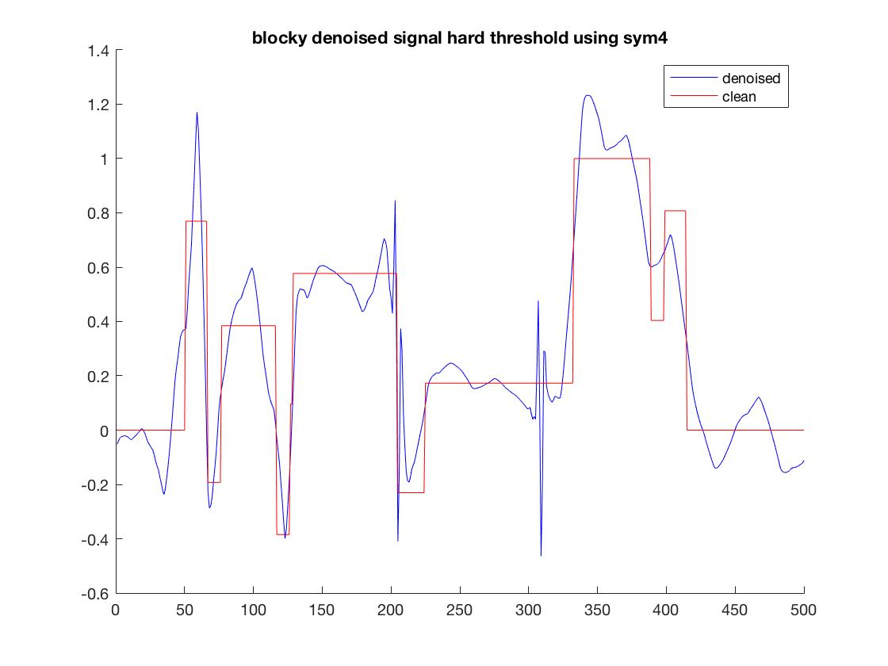

Figure 6‑7 wavelet filter-harr for denoising blocky signal

### sym4

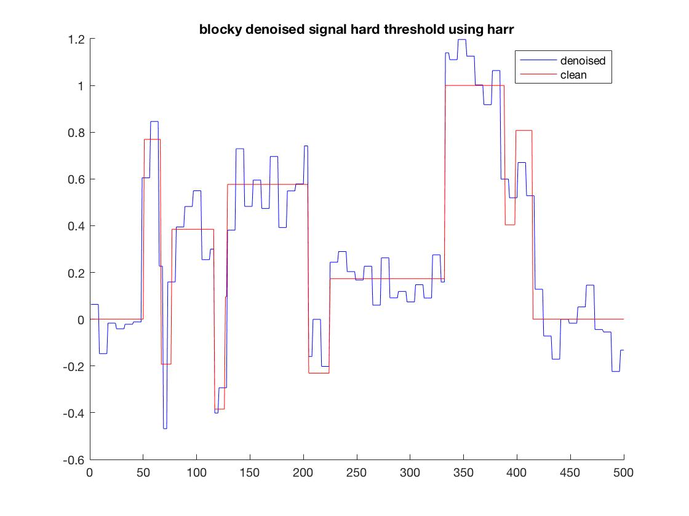

Figure 6‑8 wavelet filter-sym4 for denoising blocky signal